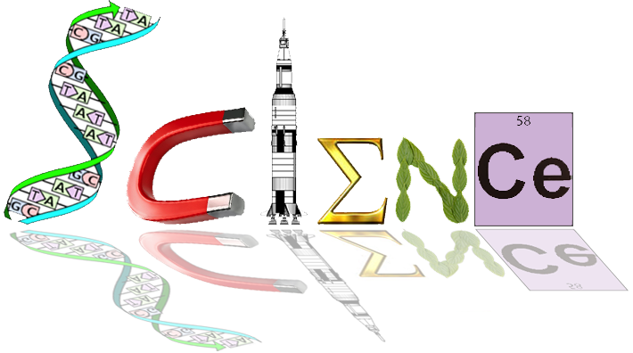

**Task 12**

**Fossils – Carbon Dating**

**/30**

**Investigation Part 1: Practical**

1. Put exactly 100 M&M’s into a paper cup (do not eat them yet – you will need all 100!). The

100 M&Ms represent carbon-14 atoms before decay.

2. Shake the cup and empty it onto a clean sheet of paper. For this activity, each shake of the cup (each run) represents one half-life.

3. Remove the M&Ms that have the label up – these are the atoms that have “decayed.”

4. Record the number of remaining, undecayed, M&Ms in the table below under Run 1.

5. Repeat this procedure with several more runs until all M&Ms are gone or until there is only one left.

6. Graph each of the data points and connect them to form a line graph.

7. Obtain the class average for each run and plot the data to make a second line on the graph.

8. Finally, calculate the theoretical half-life values for all runs and graph them as a third line. The theoretical values are based on the assumption that label-side-up and label-side-down are equally probable – for example, the theoretical value is 50 after the first run.

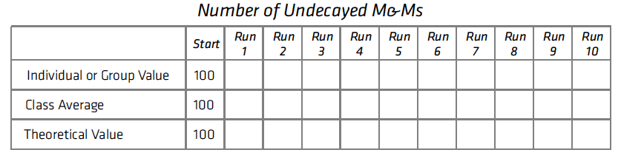9. Label the three lines on a graph.

**Graph the results on the attached graph paper** (7 marks)

Question:

Which graph line – the individual or class average – most closely follows the theoretical line? Why?

________________________________________________________________________________________________________________________________________________________________________________________________________________________

(2 marks)

**Part 2: Graphing the Decay of Carbon-14**

Knowing that the half-life of carbon-14 is 5,730 years, it is easy to construct a decay curve like the one for M&Ms. Complete the following table and make a line graph of the data on the graph paper provided. The result should be a smooth, curving line through all points.

(5 marks)

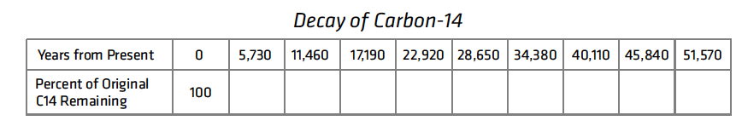

Use the graph of carbon-14 decay to solve these real-life examples.

1. In 1991, hikers in the Tyrolean Alps of Europe made a remarkable discovery. They found an almost perfectly preserved body of a prehistoric man, whom scientists named Ötzi. The discovery was made possible because recent warming of the atmosphere had caused glaciers in the region to retreat, exposing objects that had been buried under the ice for millennia. Ötzi’s fate was matched by a variety of well-preserved plant and animal species that were found close by. As discoveries of such quality are rare, the event was a genuine treasure trove for scientists. They reasoned that Ötzi and the other organisms must have been trapped by a sudden snowfall and virtually “flash frozen.” This singular event was followed immediately by an extended cold period that preserved the specimens until the present glacial retreat. Carbon dating of samples from the site established the time of Ötzi’s demise at approximately 5,300 years ago.

* What percentage of the original carbon-14 in Ötzi’s body was remaining in 1991?
* Why were these conditions good for preserving Ötzi? (3 marks)

________________________________________________________________________________________________________________________________________________________________________________________________________________________

____________________________________________________________________________________________________________

2. Scientists have been rethinking the nature of past climates. A 1998 study provided evidence that the tropics were much colder during the last glacial maximum than previously thought. Prior understanding had been that tropical regions were mostly unaffected by past ice ages.

Constructing an accurate history of ancient climates is important, since the knowledge gained may have relevance to global climate change today. In the study just mentioned, investigators used a solar-powered drill to bore through the ice cap at the summit of an extinct Bolivian volcano named Sajama. They retrieved two ice cores at the bottom of the glacier, more than 132 meters (433 feet) deep. Trapped within the cores were insects and bark fragments from local trees. Carbon from organic material near the bottom of the cores dated to the coldest period of the last ice age.

* If those samples had 5.5 percent of their original carbon-14, approximately how many years ago did the glacier atop Sajama begin to form? (1 marks)

________________________________________________________________________________________________________________________________________________________________________________________________________________________

3. The authenticity of the Shroud of Turin had long been debated. In 1988, scientists received permission to remove small samples for carbon dating. Three different laboratories in Arizona, U.S.; Oxford, England; and Zurich, Switzerland analyzed the samples. All three laboratories came to the same conclusion: The shroud had lost about 8 percent of its carbon- 14 atoms to radioactive decay.

* Given this result, what was the approximate date of origin of the Shroud of Turin?

(1 mark)

________________________________________________________________________________________________________________________________________________________________________________________________________________________

**Part 3: Relative dating**

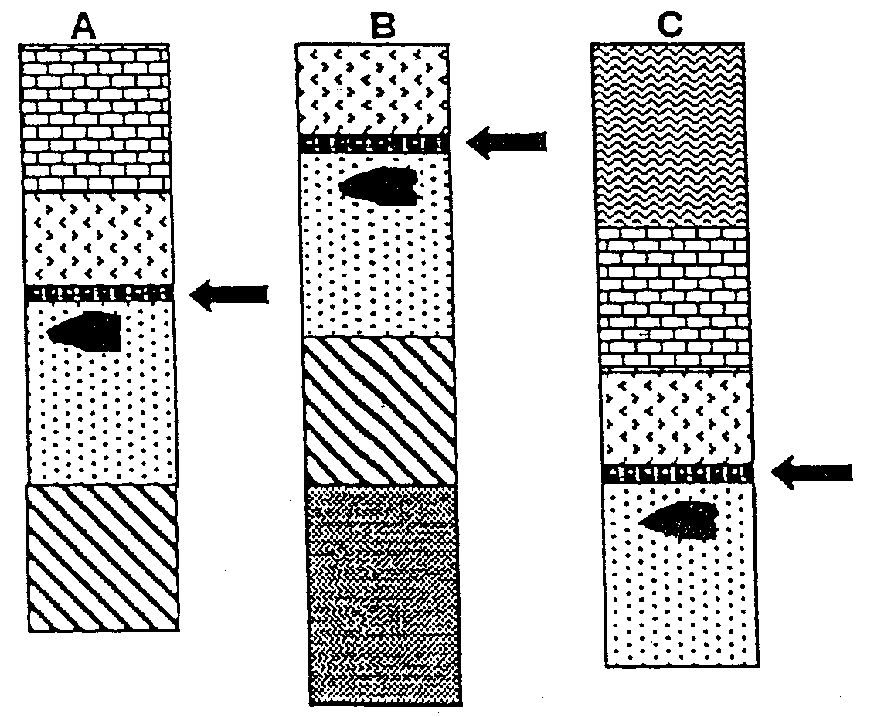

1. The three sets of layers from different archaeological dig sites shown above have suffered

differing amounts of surface erosion. A layer of volcanic ash (arrowed) has been dated to approximately 200,000‑300,000 years ago. Crudely‑made stone tools are found in all sites in a discrete layer, immediately below the ash layer. Immediately above the volcanic ash is a layer with an unusual collection of fossilized bones, from animals living on an ancient shoreline.

a) What name is given to this method of studying rock layers in archaeology? (1 mark) ____________________________________________________________________________________________________________

b) Which of the dig sites, A, B or C contains the youngest layer? (1 mark)

________________________________________________________________________________________________________________________________________________________________________________________________________________________

c) How do you know this is the youngest? (1 mark)

________________________________________________________________________________________________________________________________________________________________________________________________________________________

2. A fossilised skull and jawbone were uncovered in different locations but from the same stratum in a gravel pit at Piltdown in England. The fossils were assumed to be of the same age and became known as Piltdown Man. They were shown to be a hoax‑when fluorine analysis showed that the skull was much older than the jawbone.

a) Why might scientists have assumed the skull and jawbone to be of the same age? (1 mark)

________________________________________________________________________________________________________________________________________________________________________________________________________________________

b) Explain how fluorine analysis could show that the two fossils were of different ages.

(3 marks)

________________________________________________________________________________________________________________________________________________________________________________________________________________________

________________________________________________________________________________________________________________________________________________________________________________________________________________________

3. In 1978 a WA museum team led by Archaeologist Charles Dortch discovered some bone artefacts in a limestone cave called Devil's Lair at Margaret River. Even though they have been dated at 44,000 years old, they are so well preserved they have been identified as awls which could have been used for 'sewing' cloaks and bags.

a) State two conditions that would have led to the excellent state of preservation of these fossils. (2 marks)

________________________________________________________________________________________________________________________________________________________________________________________________________________________

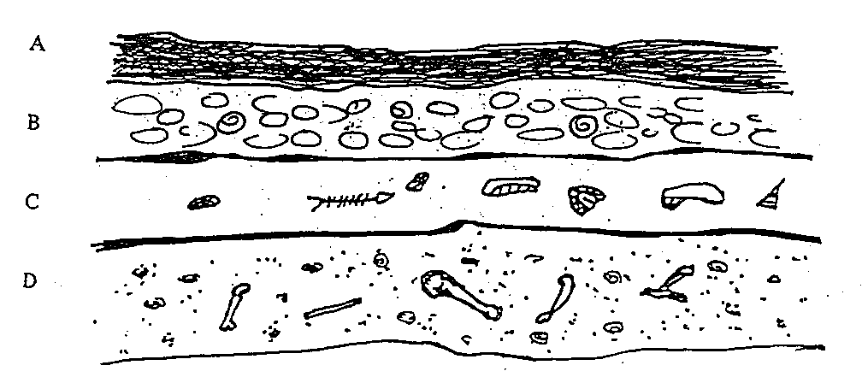

4. The diagram above shows four rock strata with some of the fossils found in these strata. Using your knowledge of fossil dating you could say that: (1 mark)

a) there are no fossils in A because it is less than 1000 years old

b) fossils in B are older than fossils in C and D

c) fossils in C are younger than fossils in B but older than those in D

d) fossils in D are older than fossils in B and C

***The diagram below represents the strata in rocks at four different locations***

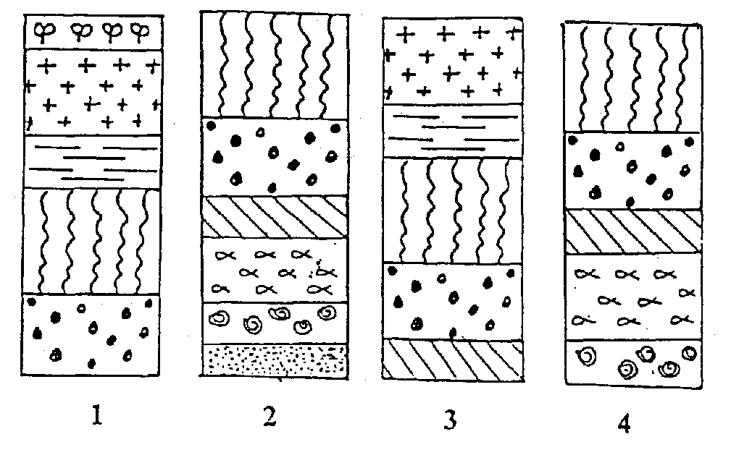

5. Which locations have the youngest and oldest rocks? (1 mark)

1. 1 ‑ youngest and 2 ‑ oldest
2. 2 ‑ youngest and 1 - oldest
3. 1 ‑ youngest and 3 ‑ oldest

d) 3 - youngest and 4 ‑ oldest